How to Guide:

Setting Up Inisope Directory and Website!

**Step 1: Creating account**

1. For the first step we will need to create an account on codeanywhere. Codeanywhere is our integrated development environment we used to test the product requested.
2. [www.codeanywhere.com](http://www.codeanywhere.com) 
3. Click on login to access my codeanywhere information or you can create your own account using the signup function.
4. 
5. Once logged in, we want to create a new containter. By going to:
6. 
7. 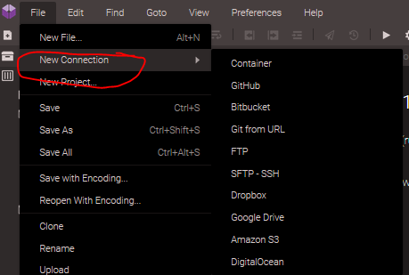
8. 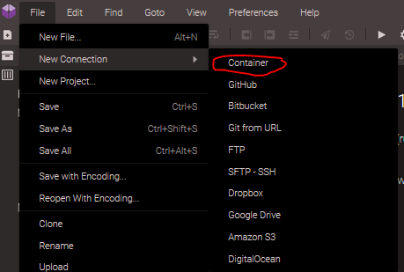
9. Once container is clicked follow these steps:
10. Select: 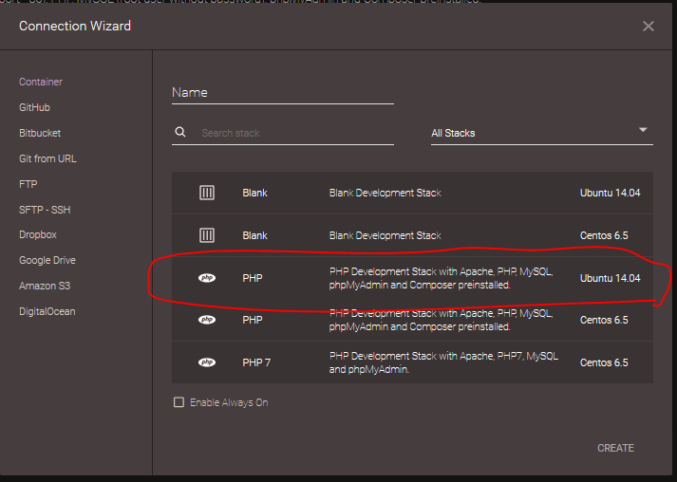
11. Give it a name such as Inisope Demo:
12. 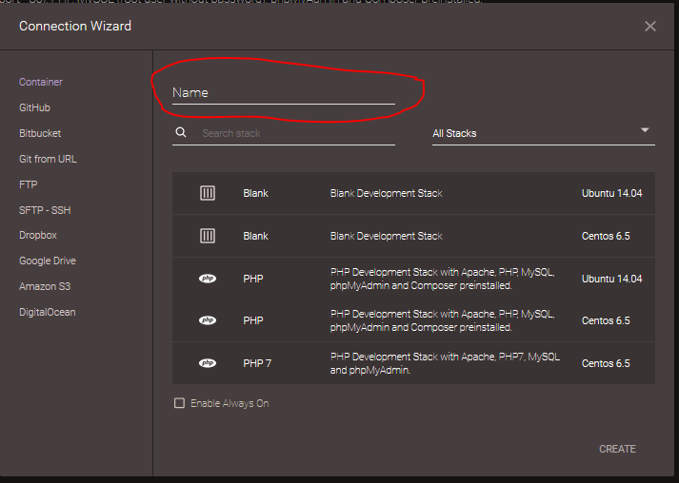
13. Once created, right click the name is the container you created and select the option as follows:
14. 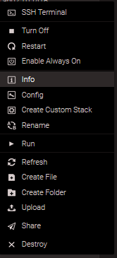
15. Once selected a file will open in codeanywhere that looks like this, to access your applications we will put in later you will follow the first link:
16. 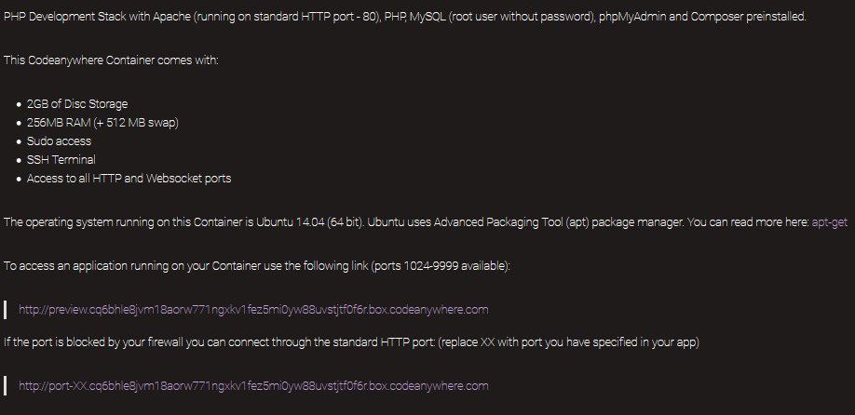
17. Once selected it will bring you to a page display like this and you want to type in at the end of the url, you want to place /phpmyadmin/. To access the sql database.
18. 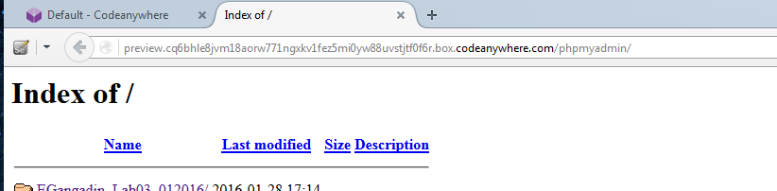
19. My link/url is <http://preview.cq6bhle8jvm18aorw771ngxkv1fez5mi0yw88uvstjtf0f6r.box.codeanywhere.com/>
20. Once you launch phpmyAdmin, you want to use my username and login to import the account csv file I have attached to this document. This will allow you to upload all the users of Inisope into a central directory.
21. 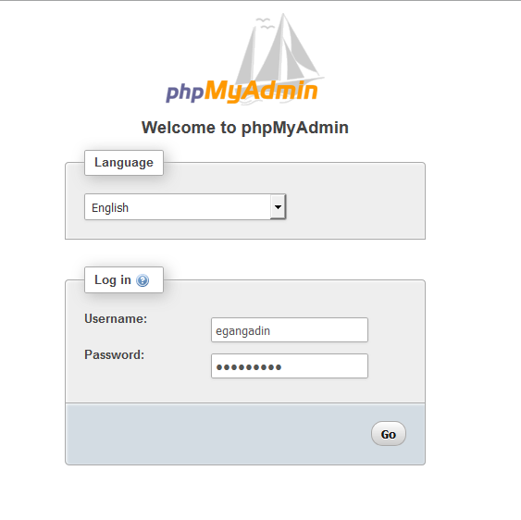
22. Password is the same as username
23. Once logged in, select Databases tab to either create a new database to or to see the demo of mine.
24. 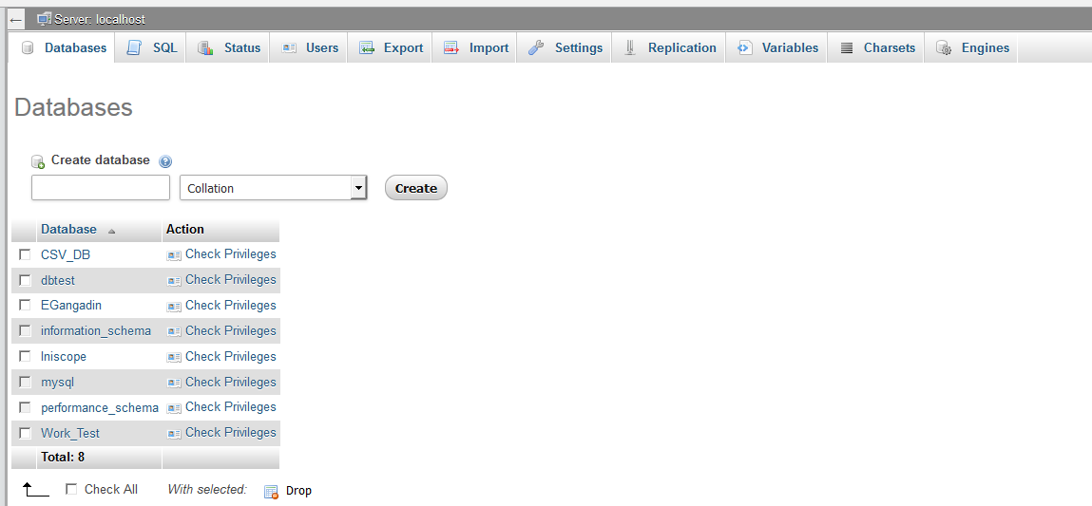
25. You can create a new database using armscii8_general_ci
26. 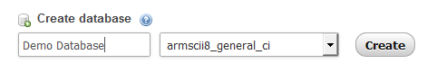
27. Once the database is created click on import, and import the accounts.csv file attached to this document. Have the settings checked off the same way as seen below.
28. 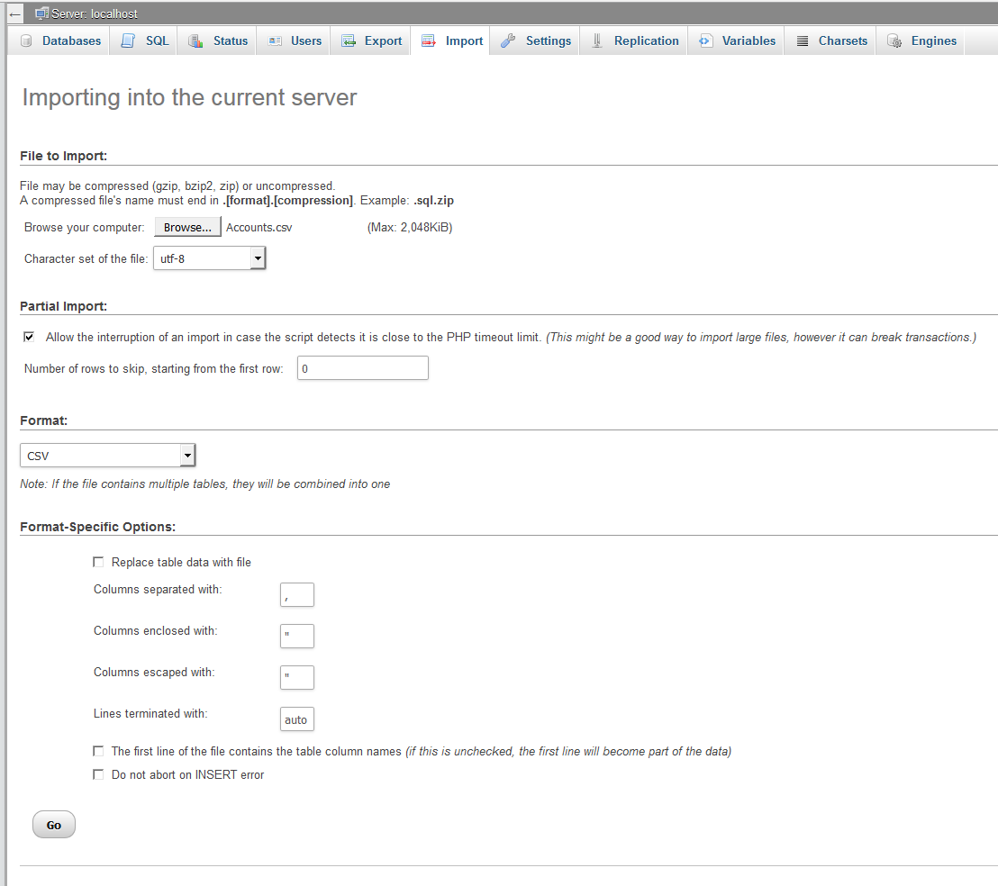
29. Now that we created our accounts database, we can go back to code anywhere. (you can verify by clicking on the users tab to see the accounts imported)
30. Back on codeanywhere we want to right click on our running container and select create new folder, name it Inisope.
31. Once inisope folder is created inside the folder I want you to create the three folders highlighted below:
32. 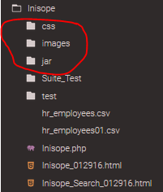
33. Once the folders are created, in each folder import the corresponding folders attached with the folders you created. It should look like this when you uploaded all files.
34. 
35. Now back to the Inisope main folder we want to upload the Inisope.php file, Inisope_012916.html, and Inisope_Search_012916.html. When completed it should look like:
36. 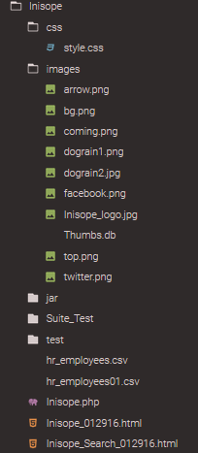
37. The Inisope and the Inisope search html are both the same page, just one is there for anything your developers would like to test.
38. Now we want to go back to the Index of our uploaded work; which would be the link from the info page mentioned in step 13.
39. <http://preview.cq6bhle8jvm18aorw771ngxkv1fez5mi0yw88uvstjtf0f6r.box.codeanywhere.com>
40. Click on Any of the Inisope html’s you have uploaded, for this demo we want to select:
41. 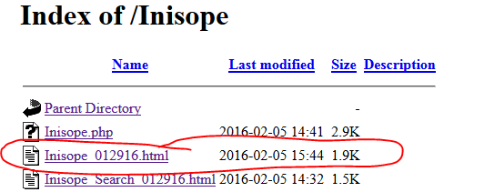
42. Which will bring you to Inisope Home Page :DDDDDD. Which should look like:
43. 
44. Scroll to the bottom of the page to search a user in the database we uploaded to sql earlier.
45. Type in any employee **last name** you want to look up or use the one I have selected as a test lookup:
46. 
47. Click on the arrow to perform the lookup.
48. 
49. The result of the page should look as follows:
50. 
51. You will see the user information you looked up, if there is more than one user with that last it will display as such.
52. If there is an issue you will like to address, please contact Veronica Rushing (lead project coordinator) or Esau Gangadin (developer), we will get back to you as soon as possible. We are pleased to work with such a great company and will like to move forward with this project.
53. If you would like to test our IDE application test runs on the search function please upload the folder named Suite_Test.
54. 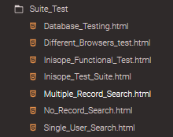
55. Each of these test perform the function listed in the title.
56. Our plan from here on out is to provide customization for Inisope website, to add and improve the current directory with the help of upper management in Inisope, we can get all necessary information needed.